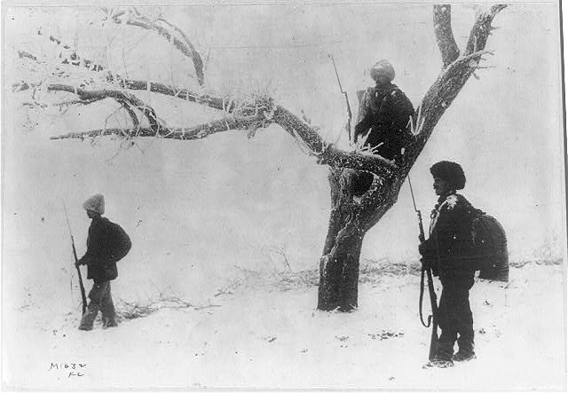

* **Title:** Serbian sentinels on guard duty
* **Creator(s):** [Underwood & Underwood](http://www.loc.gov/pictures/related/?fi=name&q=Underwood%20%26%20Underwood), copyright claimant
* **Date Created/Published:** [1914 or 1915], c1915 Apr. 27.
* **Medium:** One photographic print; 9.4 x 13.8 cm, on mount 35.7 x 28 cm.
* **Summary:** Photograph shows three Serbian soldiers on guard duty.
* **Reproduction Number:** LC-USZ62-394126 (B&W film copy neg.)
* **Rights Advisory:** No known restrictions on publication.
* **Call Number:** LOT 8880 [item] [P&P]
* **Repository:** Library of Congress Prints and Photographs Division Washington, D.C. 20540 USA http://hdl.loc.gov/loc.pnp/pp.print